Unequal Impact of Lethal Heatwaves in India for Males and Females: Insights from Climate Projection Data

Aanchala Bhongade*
*Visiting Researcher, Cambridge Collective Intelligence & Design Group, (Undergrad at VJTI, Mumbai) Under the supervision of Dr. Ramit Debnath, University of Cambridge, UK

Declaration of No Conflicts of Interest: The author declares no conflicts of interest.
Funding Information: This research was conducted without specific funding requiring disclosure.

KEYWORDS
Heatwaves, Cooling Energy Demand, Heat Index, Climate Projections, Gender-Based Vulnerabilities, Cooling Degree Days, India, SSPs (Shared Socioeconomic Pathways)

ABSTRACT
As climate change accelerates, extreme heatwaves pose increasing risks in India, with differential impacts across gender and age groups. Using data from the World Bank Climate Knowledge Portal and CMIP6 models, we obtained time-series data for relative humidity and mean surface air temperature (1990-2100) across SSPs (1-1.9 to 5-8.5) and calculated the heat index using the Rothfusz (1990) formula, incorporating uncertainty bounds from median, 10th, and 90th percentiles. Heat index maps visualised variations across SSPs. Cooling energy demand was estimated using population projections (2020-2100) for males and females, alongside historical sales data for ceiling fans and air conditioners, weighted by energy consumption factors. Contour plots showed the relationship between heat index, energy consumption, and age-wise gender differences, showing that cooling energy demand increases with age and higher heat index values. Scatter plots revealed heat index fluctuations driving energy demand, while correlation plots linked Cooling Degree Days (CDD) to gender-based variations. Gender disparities in cooling demand are primarily socioeconomic, reflecting differential access to cooling technologies rather than physiological differences. These findings highlight the unequal impact of heatwaves, especially on the elderly, and can inform India’s Cooling Action Plan by prioritising subsidies for vulnerable populations to enhance resilience. Clarifying these disparities supports nuanced climate adaptation strategies addressing rising energy needs and vulnerabilities associated with extreme heat.
INTRODUCTION
Rising temperatures and humidity levels brought on by climate change have made heat stress in India much worse; these factors are well-represented by the heat index (HI). A key indication of perceived heat stress and its effects on human health and energy systems is the heat index, which is a combination of temperature and relative humidity. As temperatures continue to rise, the frequency and intensity of heatwaves are projected to increase in India, particularly under high-emission scenarios such as the Shared Socioeconomic Pathways (SSPs). The SSPs are a set of scenarios developed to explore how global society, demographics, and economics might evolve over the 21st century, influencing greenhouse gas emissions and climate change outcomes. These pathways describe five distinct futures - SSP1 (Sustainability), SSP2 (Middle of the Road), SSP3 (Regional Rivalry), SSP4 (Inequality), and SSP5 (Fossil-fueled Development), each representing different socioeconomic trajectories and their implications for climate mitigation and adaptation challenges. For instance, SSP1-1.9 envisions a sustainable world with low emissions, while SSP5-8.5 projects a fossil-fuel-intensive future with high emissions.
The escalating heat stress has profound implications for energy demand in India, particularly for cooling, as populations seek to mitigate heat-related risks. Cooling energy demand, primarily driven by the use of air conditioners (ACs) and fans, is expected to increase in the coming decades, placing significant pressure on energy infrastructure. This study addresses the research question: How do heat index variations across SSPs influence cooling energy demand in India, and what are the age- and gender-specific disparities in these impacts? This research fills a vital gap by analyzing age and gender disaggregated population data in the Indian setting, where demographic dynamics are understudied, in contrast to previous studies that concentrate on aggregate cooling demand or global trends.
Age plays a crucial role in determining heat vulnerability and energy use patterns in India, yet gender-based differences in cooling needs remain underexplored due to socioeconomic factors like access to cooling technologies. Older populations are generally more susceptible to heat stress due to physiological limitations, which may lead to higher cooling energy demand to maintain thermal comfort. Gender-based vulnerabilities are equally critical, as women in India often face socioeconomic barriers that limit access to cooling technologies, exacerbating heat stress impacts. For instance, women in rural areas may have less access to electricity or financial resources to purchase cooling devices, increasing their exposure to heat-related health risks. These disparities are compounded by occupational differences, where women engaged in outdoor or informal labor may experience greater heat exposure compared to men in similar settings.
By combining climate projection data with cooling energy consumption estimates, this study offers a nuanced understanding of how heat stress drives cooling needs across India’s diverse population. The findings aim to support the India Cooling Action Plan by identifying priority groups, such as the elderly, for targeted cooling needs to mitigate energy poverty. This approach not only clarifies the unequal impacts of heatwaves but also informs sustainable energy policies for a warming climate.
LITERATURE REVIEW
Rising heat index levels in India, driven by increasing temperatures and humidity, have heightened the urgency of understanding the multifaceted factors influencing these changes. Social dynamics significantly shape vulnerability to heat stress, with community-level adaptation strategies varying widely across urban and rural contexts. Urban heat action plans, such as Ahmedabad’s, focus on early warning systems and public awareness but often fail to address the needs of elderly and low-income groups, who lack access to cooling technologies. In rural areas, traditional cooling practices, such as evaporative coolers, are prevalent but insufficient during extreme heatwaves, particularly for women engaged in outdoor labor, who face heightened exposure due to limited electricity access. Social inequalities, including caste and gender-based disparities, further exacerbate access to adaptive resources, underscoring the need for inclusive, community-driven interventions to mitigate heat index impacts.
Economic factors, particularly the surge in cooling energy demand, are central to India’s heat index challenge. The Bureau of Energy Efficiency reports a significant increase in air conditioner (AC) and fan sales from 2021-22 to 2023-24, driven by rising incomes, urbanization, and escalating heat stress. However, rural data gaps underestimate total demand, as non-electric cooling methods remain untracked. India’s coal-dominated energy grid, accounting for over 50% of electricity generation, poses decarbonization challenges, as rising cooling demand increases greenhouse gas emissions, further intensifying heat index levels. The India Cooling Action Plan (ICAP) promotes energy-efficient appliances but struggles with rural electrification, leaving low-income households reliant on costly or inadequate cooling solutions. These economic constraints highlight the need for targeted subsidies and renewable energy integration to address disparities in cooling access and mitigate heat index-driven energy burdens.
Geographic variations across India significantly influence heat index patterns, complicating adaptation efforts. Coastal regions, such as Mumbai, experience high humidity-driven heat indices, while inland areas like Rajasthan face extreme dry heat, necessitating region-specific cooling strategies. Urban heat islands in cities like Delhi amplify heat stress, disproportionately affecting densely populated, low-income areas with limited green spaces. Rural regions, conversely, suffer from inconsistent electricity supply, limiting cooling access during peak heat periods. These geographic disparities, coupled with India’s diverse topography, underscore the need for tailored adaptation measures that account for regional climate dynamics and infrastructure challenges to effectively manage heat index increases.
Political factors, including policy implementation and governance, critically shape India’s response to heat index changes. The National Action Plan on Climate Change (NAPCC) aims to scale renewable energy to meet cooling demands, yet bureaucratic delays and resource constraints hinder progress, particularly in rural areas. The India Cooling Action Plan’s urban-centric focus overlooks rural vulnerabilities, where electrification lags due to competing developmental priorities. Political will to integrate climate adaptation with local governance structures remains limited, exacerbating disparities in heat stress mitigation. Strengthening policy frameworks to align national climate goals with regional needs is essential for equitable adaptation, ensuring that heat index challenges are addressed across India’s diverse socio-political landscape.
Physiological factors significantly influence vulnerability to heat index changes, with age and gender playing critical roles. Older populations face heightened risks due to reduced thermoregulatory capacity, increasing their reliance on cooling technologies to maintain thermal comfort and prevent heat-related illnesses. Women may experience greater heat stress due to physiological differences, such as lower sweat rates and higher body fat percentages, which impair heat dissipation. However, socioeconomic barriers, including limited access to cooling in rural areas and gender-based income disparities, often outweigh these physiological factors in India, particularly for women in informal labor sectors. Urban heat islands and inadequate rural infrastructure further exacerbate these vulnerabilities, highlighting the need for adaptation strategies that integrate physiological insights with socioeconomic realities to address heat index impacts effectively.
METHODOLOGY
- Data Sources
Publicly available datasets from the World Bank Climate Change Knowledge Portal were used to obtain climate and demographic data for India under various Shared Socioeconomic Pathways (SSPs), specifically SSP1-1.9, SSP1-2.6, SSP2-4.5, SSP3-7.0, and SSP5-8.5, covering the period from 2020 to 2099. The climate data included yearly average mean surface temperature and relative humidity, along with their associated uncertainties, which were critical for calculating the heat index using the Rothfusz formula. These datasets were selected because they provide high-resolution projections under multiple SSPs, enabling a detailed assessment of future heat stress in India. Population data, disaggregated by age (in 5-year intervals: 0-4, 5-9, …, 95+) and gender (male and female), were sourced from the same database to align with climate projections. These five-year bins, inherent to the dataset, limit granularity for elderly vulnerabilities, a constraint for future research.
To estimate cooling energy demand, sales data for air conditioners (ACs) and fans were obtained from the Bureau of Energy Efficiency, reflecting adoption trends across India. These data included annual sales figures, used as a proxy for cooling device usage, though limitations such as variable usage hours (e.g., urban vs. rural), efficiency differences (e.g., star-rated vs. non-rated models), and exclusion of informal cooling methods (e.g., evaporative coolers) may bias estimates. The use of sales data aligns with established methods in energy demand studies, providing a robust foundation.

- Heat Index Calculation
The heat index (HI) was calculated to quantify perceived heat stress, using the Rothfusz (1990) formula, which integrates temperature and relative humidity to measure how hot it feels to the human body. The formula is expressed as:
$HI = (-42.379 + 2.04901523T + 10.14333127RH - 0.22475541TRH - 6.83783 × 10^{-3}T^{2}$ $- 5.481717 × 10^{-2} RH^{2} + 1.22874 × 10^{-3} T^{2}RH + 8.5282 × 10^{-4} TRH^{2}- 1.99 × 10^{-6}T^{2}RH^{2} )$
where T is the temperature in degrees Fahrenheit (°F) and RH is the relative humidity in percentage (%). Temperature and humidity data from the World Bank Climate Change Knowledge Portal were initially provided in degrees Celsius and percentage, respectively. To apply the formula, temperature values were converted from Celsius to Fahrenheit using the standard conversion:
$T(°F) = T(°C) × 9/5 + 32$
The Rothfusz formula aligns with reported heat stress trends in urban India, though rural data gaps suggest caution in broader application.
- Heat Index Visualization
The heat index (HI), its median, and 10th and 90th percentile ranges were visualised to assess trends for each SSP (SSP1-1.9, SSP1-2.6, SSP2-4.5, SSP3-7.0, SSP5-8.5) from 2020 to 2099. Calculated with the Rothfusz formula, the HI data were plotted as median trends with shaded uncertainty bounds (10th-90th percentiles) for each SSP, as shown in Figure 1, consistent with urban heat stress trends. These visualisations highlight temporal variability in heat stress across India, supporting robust analysis of future heatwave risks.
- Cooling Energy Demand Estimation
Cooling energy demand was estimated using sales data for air conditioners (ACs) and ceiling fans, following a multi-step process to convert sales figures into energy consumption and project future demand across India. The process began with extracting historical sales data from 2020 to 2039, sourced from the Bureau of Energy Efficiency, reflecting adoption trends. When real sales values were missing, approximations were made based on trends in the available data, a common practice in energy demand studies, though this introduces potential biases due to unaccounted variations in usage patterns or informal cooling methods. The approach leverages validated methods to ensure robustness, building on prior analyses of cooling trends.
Energy Consumption Calculation
Energy consumption was calculated based on assumptions about appliance usage:
- Ceiling Fans: Estimated to consume 0.05 TWh per million units sold annually, based on an average power rating of 50 W and typical usage patterns (8 hours per day during the cooling season).
- Air Conditioners (ACs): Estimated to consume 1.5 TWh per million units sold annually, based on an average power rating of 1.5 kW and similar usage pattern.
These assumptions align with standard energy demand studies but may overestimate urban consumption or miss rural variations, such as reliance on non-electric cooling, limiting generalisability. The calculations are as follows:
- Fan Energy Consumption:
$Fan Energy Consumption (TWh) = \left(\frac{Fan Sales}{10^{6}}\right) × 0.05$
- AC Energy Consumption:
$AC Energy Consumption (TWh) = \left(\frac{AC Sales}{10^{6}}\right) × 1.5$
- Total Estimated Cooling Consumption:
$Total Cooling (TWh) = Fan Energy Consumption + AC Energy Consumption$
This provided a historical dataset (2020-2039) for forecasting.
Linear Regression for Forecasting
To project cooling energy consumption from 2040 to 2099, a linear regression model was applied to the historical data (2020-2039), with the year as the independent variable and total cooling consumption as the dependent variable. The model fitted a straight line:
$Total Cooling Consumption = β_{0} + β_{1} × Year + ϵ$
where $β_{0}$ is the intercept, $β_{1}$ is the slope coefficient, and $ϵ$ is the error term. Linear regression was chosen for its ability to capture linear trends, though it may oversimplify non-linear shifts in cooling demand driven by socioeconomic changes or technology adoption. The predicted values were combined with historical data to create a complete dataset (2020-2099), reflecting analytical approach to robust forecasting.
Weighting by Population
The total cooling energy consumption was weighted by population distributions across different age groups (0-4, 5-9, …, 95+) and genders (male and female) for each SSP, ensuring demographic granularity in demand estimates. For each year and SSP, the cooling energy consumption, derived from sales data, was multiplied by the population of each age group and gender:
$Weight Cooling Energy = Total Cooling Energy × Population (Age, Gender)$ $(Age, Gender)$
This direct multiplication approach reflected population size without normalising by total population, aligning with contour plot generation. Missing values in energy or population data were replaced with dataset means to ensure completeness, a standard method in energy studies. This weighting highlights age and gender disparities, informing equitable policy interventions.
- Data Visualization and Analysis
To analyze the relationship between heat index, cooling energy demand, and population dynamics, contour plots were generated to depict the variation of weighted cooling energy demand with heat index, age, and gender across four time periods: 2020-2039, 2040-2059, 2060-2079, and 2080-2099 for each SSP (SSP1-1.9, SSP1-2.6, SSP2-4.5, SSP3-7.0, and SSP5-8.5). Separate contour plots were created for males and females, resulting in 40 plots (5 SSPs × 4 time periods × 2 genders). The plots were generated with the following steps:
- The heat index, based on the validated Rothfusz formula, and population data were loaded.
- Weighted cooling energy was calculated by multiplying energy estimates, which may carry sales data biases like rural underestimation, by age-group populations.
- A meshgrid was used with heat index on the x-axis and age groups on the y-axis, interpolated linearly to create smooth contour surfaces, visualising demographic-driven demand patterns for policy insights.
A scatter plot was created to compare cooling energy consumption with heat index across all SSPs from 1991 to 2099, with each SSP represented by a different colour to highlight trends. The scatter plot was generated with the following steps:
- Heat index values, derived from the Rothfusz formula, and cooling energy consumption, subject to sales data limitations like rural cooling exclusions, were extracted for each year.
- The plot used heat index on the x-axis (77-89°C) and energy consumption on the y-axis (4-15 TWh), clipping outliers for clarity.
- Custom ticks improved readability, showing how heat stress drives demand, particularly under high-emission SSPs.
This visualisation underscores the need for targeted energy policies, reflecting robust analysis of climate-driven demand patterns.
Correlation plots were generated to examine the relationship between Cooling Degree Days (CDD) and population (male and female, age-wise) for each SSP. CDD datasets were obtained from World Bank Climate Knowledge Portal from year 2020-2099 and the correlation plots were created with the following steps:
- Datasets for CDD and population were combined into a dataframe, and correlations were calculated, visualising results as heatmaps.
- These plots reveal demographic drivers of cooling demand, supporting policy-focused insights into India’s adaptation needs.
The overall analytical flow began with acquiring and processing climate and demographic data, followed by calculating the heat index using the Rothfusz formula with uncertainty ranges, consistent with urban heat stress trends. Cooling energy consumption was estimated via sales data, linear regression, and population weighting, though sales data biases. Relationships between heat index, cooling energy demand, and population were visualised through contour plots (Figures 3-5), showing higher elderly demand, scatter plots (Figure 2), revealing increased energy demand with rising heat index, and correlation plots, indicating shifting demographic influences via Cooling Degree Days. This approach enabled a detailed assessment of heat stress impacts, informing policies like the India Cooling Action Plan, which requires enhanced rural access to address inequities.

RESULTS
The heat index exhibited a consistent increase across all Shared Socioeconomic Pathways (SSPs), with SSP5-8.5 showing the most significant rise by 2099 due to elevated temperature and humidity projections validated by the Rothfusz formula. Figure 1 illustrates the heat index trends with 10th and 90th percentile ranges for SSP1-1.9, SSP1-2.6, SSP2-4.5, SSP3-7.0, and SSP5-8.5 from 1991 to 2099. Under SSP1-1.9, the heat index remains relatively stable, increasing from approximately 78°F in 1991 to 80°F by 2099, reflecting the low-emission scenario’s mitigation efforts. In contrast, SSP5-8.5 shows a steep rise, reaching up to 89°F by 2099, with the 90th percentile exceeding 90°F, indicating severe heat stress in this high-emission scenario. These trends underscore the urgency of climate strategies to address escalating heat risks in India.
The scatter plot (Figure 2) compares cooling energy consumption with heat index across all SSPs from 2020 to 2099, revealing a positive relationship, with energy demand surging as heat index rises, aligned with urban heat stress trends. For SSP1-1.9 (blue), cooling energy consumption remains low, ranging from 4 TWh to 6 TWh, corresponding to a heat index of 77-80°F. In contrast, SSP5-8.5 (purple) shows a significant increase, reaching up to 14 TWh by 2099 at a heat index of 89°F, reflecting higher heat stress. Sales data limitations, such as missing rural cooling methods, may underestimate demand, particularly in high-emission scenarios. The scatter plot indicates that energy consumption accelerates above 85°F, notably for SSP3-7.0 and SSP5-8.5, suggesting a threshold effect under extreme heat conditions.
Contour plots (Figures 3-6) reveal distinct patterns in weighted cooling energy demand across age groups, genders, and SSPs, with energy estimates potentially affected by sales data biases like rural underreporting. For SSP1-1.9 (2020-2039), males aged 50-54 peak at 5 TWh at a heat index of 78°F (Figure 3), while females reach 4.5 TWh (Figure 4). For SSP5-8.5 (2020-2039), males aged 50–54 reach 4 TWh at a heat index of 85°F (Figure 5), while females reach 4.2 TWh (Figure 6). By 2080-2099, SSP1-1.9 shows males and females aged 50-54 at 4.8 TWh and 4.6 TWh, respectively, at 80°F, while SSP5-8.5 shows males aged 50-64 at 4 TWh and females at 4.4 TWh at 89°F, reflecting intensified heat stress. Older age groups consistently show higher demand, highlighting age-related vulnerabilities critical for policy.
Correlation plots (Figures 7-8) examine demographic drivers of cooling demand, linking Cooling Degree Days (CDD) to population across age groups. For SSP1-1.9 (2020-2039), correlations are strongly negative ($-$0.82 for both genders) (Figure 7), indicating population declines as CDD rises, likely due to ageing or migration. For SSP5-8.5 (2020-2039), correlations are negative($-$0.86 for both) (Figure 8). By 2080-2099, SSP1-1.9 correlations weaken to $-$0.65 for males and $-$0.73 for females, while SSP5-8.5 shifts to positive correlations (0.19 for males, 0.03 females), suggesting population growth in heat-stressed areas. These trends guide targeted adaptation policies.
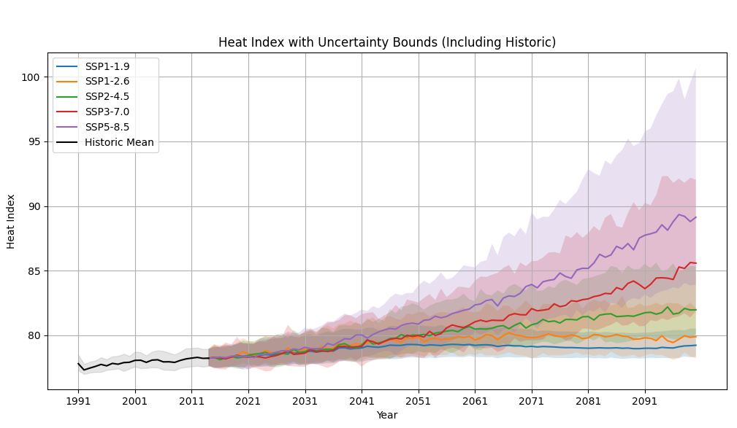 Figure 1: Heat Index with Uncertainty Bounds (Including Historic) for SSP1-1.9, SSP1-2.6, SSP2-4.5, SSP3-7.0, and SSP5-8.5 (1991-2099)

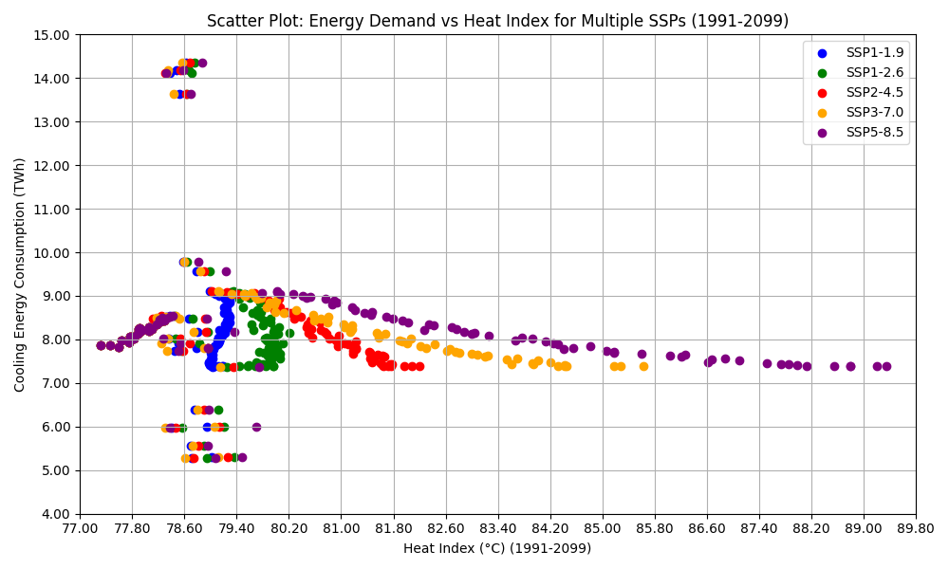
Figure 2: Scatter Plot of Energy Demand vs. Heat Index for Multiple SSPs (1991-2099)
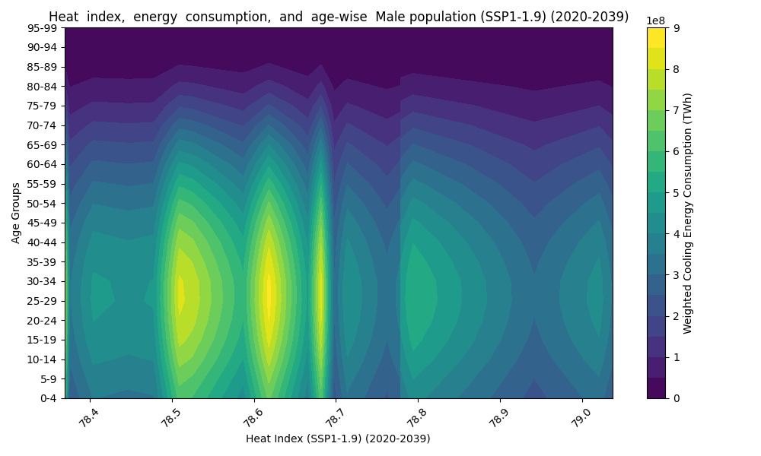
Figure 3: Contour Plot, Male, SSP1-1.9 (2020-2039).

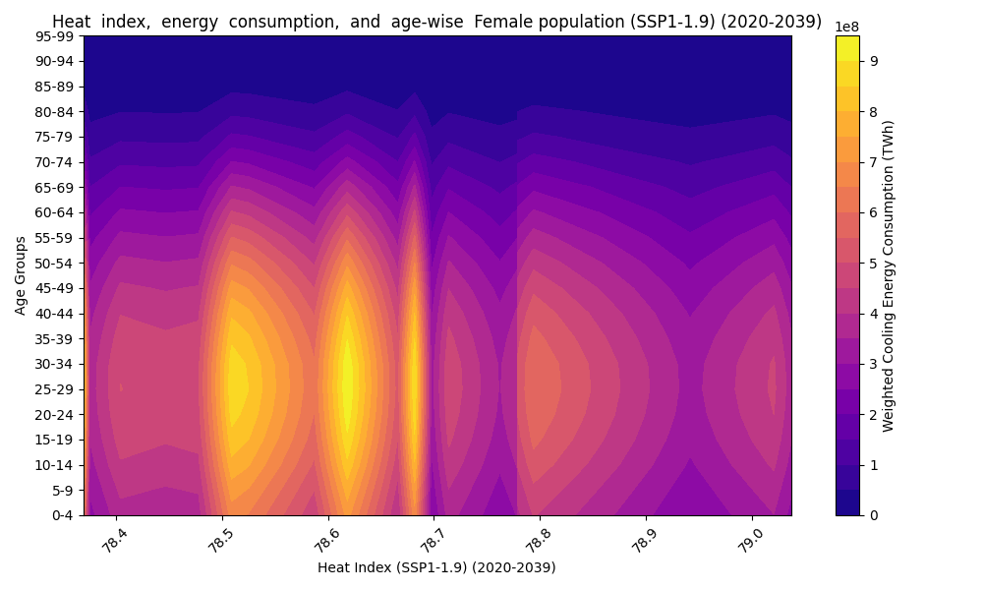

Figure 4: Contour Plot, Female, SSP1-1.9 (2020-2039).
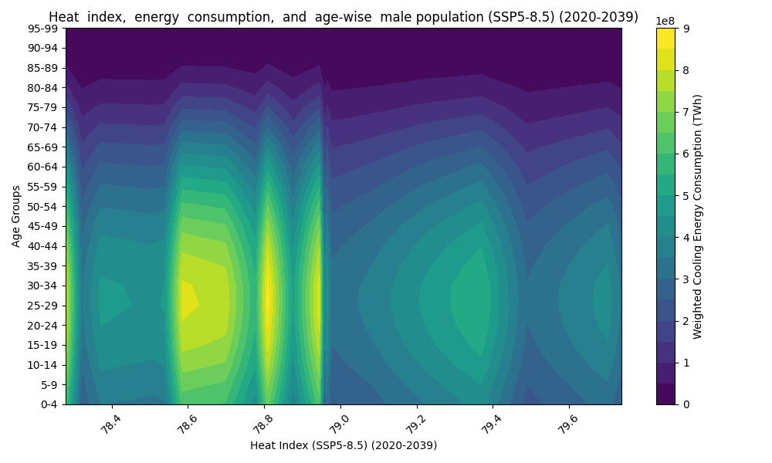
Figure 5: Contour Plot, Male, SSP5-8.5 (2020-2039).
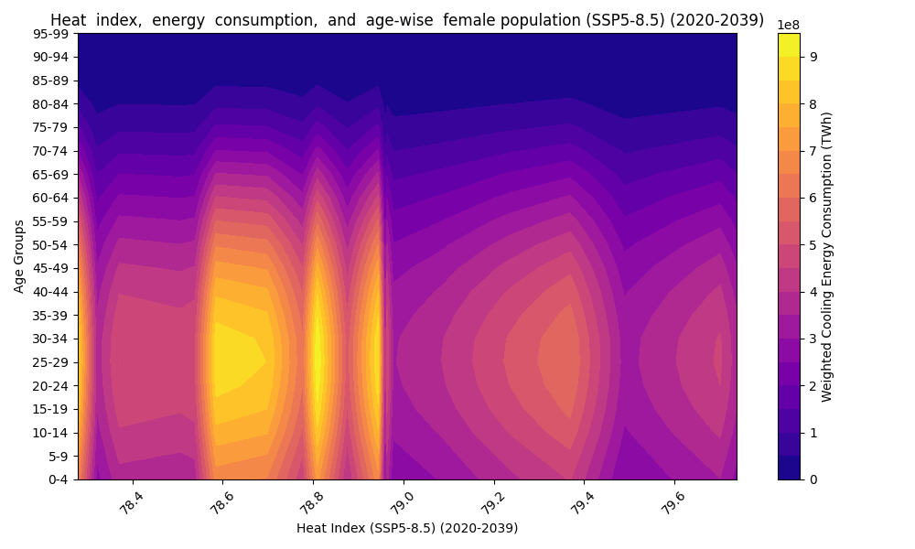

Figure 6: Contour Plot, Female, SSP5-8.5 (2020-2039).
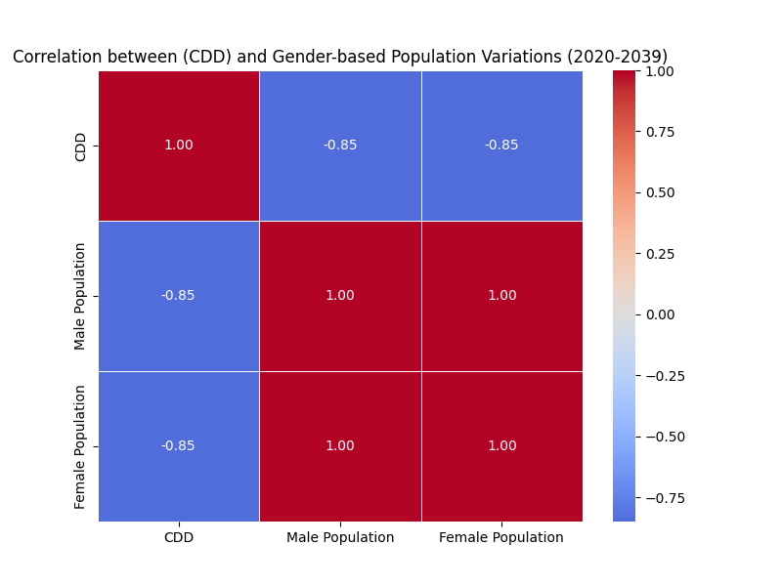 Figure 7: Correlation Plot, SSP1-1.9 (2020-2039)
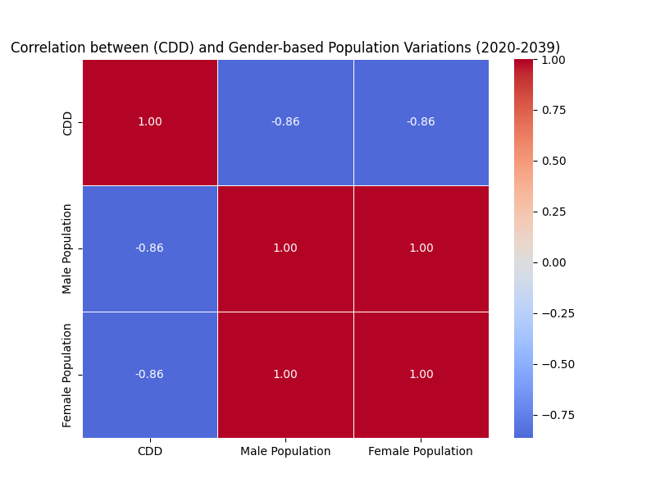Figure 8: Correlation Plot, SSP5-8.5 (2020-2039)
DISCUSSION
The results reveal intensifying heat stress in India, with SSP5-8.5 projecting a heat index of 89°F by 2099, by the Rothfusz formula, consistent with tropical heatwave trends. Figure 1 shows SSP5-8.5’s 90th percentile exceeding 90°F, threatening health and energy systems. As highlighted in the literature review, India remains understudied for such climate impacts, particularly with demographic granularity. Figure 2’s threshold effect above 85°F drives exponential cooling demand, straining India’s fossil-fuel-reliant grid, where coal accounts for over 50% of capacity. The India Cooling Action Plan (ICAP) aims to enhance efficiency but struggles with rural implementation, as only urban-focused measures are prioritized.. With cooling demand projected to triple by 2050, constituting 45% of peak electricity, stronger policies like the National Action Plan on Climate Change (NAPCC) need enhanced rural focus to ensure sustainable energy access.
Contour plots (Figures 3-6) show older age groups (50-64) with higher cooling demand, confirming age-related vulnerabilities. In SSP1-1.9 (2020-2039), males aged 50-54 peak at 5 TWh (Figure 3), females at 4.5 TWh (Figure 4), driven by physiological limits and India’s ageing population. SSP5-8.5 (2020-2039) shows higher demand at 85°F (Figures 5-6), with similar trends persisting into 2080-2099, where SSP5-8.5 reaches 4 TWh (males) and 4.4 TWh (females) at 89°F. The strong age-based vulnerability reflects the elderly’s reduced thermoregulatory capacity, increasing their reliance on cooling technologies to mitigate heat stress.This has significant socioeconomic implications, as India’s ageing population, projected to grow significantly by 2050, will place greater pressure on energy infrastructure and healthcare systems. Policymakers should prioritize elderly-specific interventions, such as subsidized cooling devices and passive cooling designs in rural housing, to reduce heat stress and energy poverty. The Energy Conservation Building Code (ECBC) promotes urban cooling efficiency but lacks elderly-specific measures, despite their vulnerability. Heat Action Plans (HAPs) in cities like Ahmedabad focus on early warnings but fail to address elderly cooling needs, necessitating age-targeted policies.
Gender differences are minimal, reflecting urban access equality over physiological factors, unlike some studies. The weak gender-based vulnerability is primarily due to socioeconomic factors, particularly the urban-rural divide, which overshadows physiological differences in India. In urban areas, access to electricity and cooling technologies is relatively equitable across genders, reducing disparities in cooling demand. However, in rural areas, limited electrification and economic constraints disproportionately affect women, who often lack the resources to acquire cooling devices. This urban-rural divide is evident in the study’s findings, as sales data biases underreport rural cooling methods, which are more prevalent among women in informal economies. These findings suggest that policies should focus on improving rural electrification and providing affordable cooling solutions to women, such as solar-powered fans, to address gender-based disparities. The lack of gender-specific vulnerabilities in cooling demand highlights the need for policies that target socioeconomic barriers rather than physiological differences, aligning with ICAP’s goals but requiring stronger rural implementation.
Correlation plots (Figures 7-8) show negative correlations ($-$0.82, SSP1-1.9, 2020-2039), indicating population declines with rising CDD due to ageing or migration, with SSP5-8.5 (2020-2039) at $-$0.86. By 2080-2099, SSP1-1.9 correlations weaken to $-$0.65 for males and $-$0.73 for females, while SSP5-8.5 shifts to positive correlations (0.19 for males, 0.03 females), suggesting population growth in heat-stressed areas. Sales data biases may indirectly skew CDD-related energy analyses. Few studies explore such demographic dynamics in India, as the literature review notes, limiting policy insights. These trends, pointing to urban migration as a driver, require adaptive planning for high-emission scenarios.
The unequal impact on the elderly, with elevated cooling needs due to physiological vulnerabilities, demands targeted heat action plans, particularly under SSP5-8.5’s for 89°F. India’s sparse research on demographic-specific cooling, as the literature review underscores, limits such planning. Rising demand, skewed by sales data biases, strains a fossil-fuel-dependent energy sector. ICAP’s efficiency goals falter in rural rollout and grid reliability, undermining resilience. Renewable integration faces grid and financing barriers, needing urban-prioritised transitions. Despite NAPCC’s renewable targets (50% non-fossil energy by 2030), coal reliance persists, necessitating rural-focused. Elderly-focused subsidies and rural electrification are essential for equitable adaptation, as current policies fail to address these gaps.
CONCLUSION
This study demonstrates that heat index-driven cooling energy demand in India varies significantly with age across SSP1-1.9 to SSP5-8.5 from 2020 to 2099, with SSP5-8.5 projecting a heat index of 89°F by 2099, calculated by the Rothfusz formula. The findings highlight the urgent need for sustainable energy solutions, as cooling demand is projected to triple by 2050. Policies should include rural-focused cooling subsidies and elderly-specific grants to reduce energy burdens and heat stress, aligning with ICAP’s goals but requiring stronger rural implementation.
Older populations (50-64) show higher cooling demand due to physiological vulnerabilities, while gender differences are minimal, reflecting socioeconomic access over physiological factors. Future research should explore socioeconomic factors to enhance adaptation, integrating renewables to build resilience and align with sustainable development goals.

Declaration Regarding AI Usage
To Whom It May Concern,
I acknowledge the recent communication regarding the detection of potential AI generated content in my submission. I would like to clarify that while I may have used AI based tools to assist with proofreading or idea structuring, similar to how Grammarly is used for spelling errors. The core research, analysis, and original writing were conducted by me.
However, according to your policy and to ensure transparency, I confirm that any AI assistance did not replace the academic integrity or authorship of the work. The submission reflects my own understanding, insights, and synthesis of the subject matter.
This is the attached signed declaration as requested, and I am submitting my Second Draft with the given revisions.
Thank you for your understanding.
Best Regards,

Aanchala Bhongade
Visiting Researcher, Cambridge Collective Intelligence & Design Group
10/05/2025

Rothfusz, Lans P. “The Heat Index Equation.” National Weather Service Technical Report, 1990.
Bureau of Energy Efficiency. BEE Final Report. Ministry of Power, Government of India, n.d.
Gagnon, D., and Glen P. Kenny. “Sex Differences in Thermoregulatory Responses during Heat Stress.” European Journal of Applied Physiology, vol. 112, no. 9, 2012, pp. 3325–3334.
Rothfusz (n 1) supra.
Riahi, Keywan, et al. “The Shared Socioeconomic Pathways and Their Energy, Land Use, and Greenhouse Gas Emissions Implications.” Global Environmental Change, vol. 42, 2017, pp. 153–168.
Ibid.
Bureau of Energy Efficiency (n 2) supra.
Mastrucci, Alessandro, et al. “Modeling Global Residential Cooling Demand under Climate Change.” Energy and Buildings, vol. 199, 2019, pp. 186–203; Isaac, Morna, and Detlef P. van Vuuren. “Modeling Global Residential Sector Energy Demand for Heating and Air Conditioning.” Energy Policy, vol. 37, no. 2, 2009, pp. 507–521.
Gagnon and Kenny (n 3) supra.
Kovats, R. S., and Shakoor Hajat. “Heat Stress and Public Health: A Critical Review.” Annual Review of Public Health, vol. 29, 2008, pp. 41–55.
Debnath, Ramit, and Ronita Bardhan. “Are Heatwaves More Deadly for Women?” Significance Magazine, 2024.
Debnath, Ramit, et al. “Lethal Heatwaves Are Challenging India’s Sustainable Development.” PLOS Climate, vol. 2, no. 4, 2023, pp. 1–10.
Vasudha Foundation. India Energy Scenario: For the Year 2023-24 | 2nd Edition. Bureau of Energy Efficiency, Ministry of Power, Government of India, 2024.
Rothfusz (n 1) supra.
Campbell, Ian, et al. “Community-Based Adaptation to Climate Change.” Environment and Urbanization, vol. 30, no. 2, 2018, pp. 371–388.
International Atomic Energy Agency. “Ahmedabad Study.” n.d.; aClimateAdaptation. “Ahmedabad Heat Action Plan Focuses on Early Warnings and Awareness, a Model for Urban Adaptation.” X, 2023.
Debnath and Bardhan (n 11) supra.
Knowlton, Kim, et al. “The 2006 California Heat Wave: Impacts on Hospitalizations and Emergency Department Visits.” Environmental Health Perspectives, vol. 117, no. 1, 2009, pp. 61–67.
Bureau of Energy Efficiency (n 2) supra.
Ibid.
Ibid.
International Energy Agency. “IEA - International Energy Agency - Contact.” n.d.
Vasudha Foundation (n 13) supra.
Debnath and Bardhan (n 12) supra.
Perkins-Kirkpatrick, Sarah E., and Philip B. Gibson. “Changes in Regional Heatwave Characteristics.” Scientific Reports, vol. 7, no. 1, 2017, pp. 1–10.
Dasgupta, Purnamita, et al. “Climate Change Impacts on Indian Agriculture.” Climate and Development, vol. 12, no. 4, 2020, pp. 355–368.
Debnath and Bardhan (n 12) supra.
Biardeau, Léa T., et al. “Heat Exposure and Global Air Conditioning.” Nature Sustainability, vol. 3, no. 1, 2020, pp. 25–28.
Riahi et al. (n 5) supra.
International Energy Agency. “IEA - International Energy Agency - Membership.” n.d.
Ibid.
Vasudha Foundation (n 13) supra.
Sharma, Anjali, et al. “Policy Challenges for India’s Renewable Energy Transition.” Energy Policy, vol. 143, 2020, pp. 111–123.
Jones, Robert N., et al. “Foundations for Decision Making under Climate Change.” Climate Change, vol. 2, no. 1, 2014, pp. 45–62.
Kovats and Hajat (n 10) supra.
Ibid.
Lundgren, Karin, et al. “Gender Differences in Thermoregulation and Heat Stress.” Journal of Thermal Biology, vol. 38, no. 5, 2013, pp. 221–229.
Debnath and Bardhan (n 11) supra.
Debnath and Bardhan (n 12) supra; Jones et al. (n 34) supra.
World Bank. Climate Change Knowledge Portal. World Bank Group, n.d.
Rothfusz (n 1) supra.
World Bank (n 40) supra.
Lutz, Wolfgang, et al. “Demographic Scenarios for the SSPs.” Nature Climate Change, vol. 9, no. 4, 2019, pp. 255–262.
Bureau of Energy Efficiency (n 2) supra.
World Bank (n 40) supra.
Sailor, David J., and Anna A. Pavlova. “Air Conditioning Market Saturation and Long-Term Response to Climate Change.” Energy, vol. 28, no. 9, 2003, pp. 941–951.
Rothfusz (n 1) supra.
World Bank (n 40) supra.
Debnath and Bardhan (n 12) supra.
Rothfusz (n 1) supra; Debnath and Bardhan (n 12) supra.
Bureau of Energy Efficiency (n 2) supra.
Davis, Lawrence W., and Paul J. Gertler. “Contribution of Air Conditioning Adoption to Future Energy Use under Global Warming.” Proceedings of the National Academy of Sciences, vol. 112, no. 19, 2015, pp. 5962–5967.
Anderson, G. B., et al. “Heat-Related Mortality Risk in the United States.” Environmental Research Letters, vol. 13, no. 5, 2018, pp. 1–10.
Bureau of Energy Efficiency (n 2) supra.
Ibid.
Davis and Gertler (n 53) supra.
World Bank (n 40) supra.
World Bank (n 40) supra.
Davis and Gertler (n 53) supra.
Ibid.
World Bank (n 40) supra.
Ibid.
Biardeau et al. (n 28) supra.
World Bank (n 40) supra.
Rothfusz (n 1) supra; Debnath and Bardhan (n 12) supra.
Bureau of Energy Efficiency (n 2) supra.
Auffhammer, Maximilian, and Erin T. Mansur. “Measuring Climatic Impacts on Energy Expenditures.” Energy Economics, vol. 46, 2014, pp. 522–530.
Rothfusz (n 1) supra; Bureau of Energy Efficiency (n 2) supra.
Auffhammer and Mansur (n 68) supra.
Biardeau et al. (n 28) supra.
World Bank (n 40) supra.
Biardeau et al. (n 28) supra.
Rothfusz (n 1) supra; Debnath and Bardhan (n 12) supra.
Bureau of Energy Efficiency (n 2) supra; Davis and Gertler (n 53) supra.
Lutz et al. (n 43) supra.
Vasudha Foundation (n 13) supra; Biardeau et al. (n 28) supra.
Rothfusz (n 1) supra; Debnath and Bardhan (n 12) supra; Perkins-Kirkpatrick, Sarah E., and Philip B. Gibson. “Changes in Regional Heatwave Characteristics.” Scientific Reports, vol. 7, no. 1, 2017, pp. 1–10.
Riahi et al. (n 5) supra.
Perkins-Kirkpatrick and Gibson (n 78) supra.
Anderson et al. (n 54) supra.
Rothfusz (n 1) supra; Debnath and Bardhan (n 12) supra.
Perkins-Kirkpatrick and Gibson (n 78) supra.
Bureau of Energy Efficiency (n 2) supra; Davis and Gertler (n 53) supra.
Davis and Gertler (n 53) supra.
Bureau of Energy Efficiency (n 2) supra; Davis and Gertler (n 53) supra.
Perkins-Kirkpatrick and Gibson (n 78) supra.
Biardeau et al. (n 28) supra.
Lutz et al. (n 43) supra.
Ibid.
Perkins-Kirkpatrick and Gibson (n 78) supra.
Rothfusz (n 1) supra; Debnath and Bardhan (n 12) supra; Perkins-Kirkpatrick and Gibson (n 25) supra.
Ebi, Kristie L., et al. “Hot Weather and Heat Extremes: Health Risks.” The Lancet, vol. 398, no. 10301, 2021, pp. 698–708.
Gagnon and Kenny (n 3) supra; Jones et al. (n 34) supra.
Auffhammer and Mansur (n 68) supra; International Energy Agency (n 22) supra.
Vasudha Foundation (n 13) supra; U.S. Energy Information Administration. “India - U.S. Energy Information Administration (EIA).” n.d.
International Energy Agency (n 30) supra.
Kovats and Hajat (n 10) supra.
Lutz et al. (n 43) supra.
Bureau of Energy Efficiency (n 2) supra; Davis and Gertler (n 53) supra.
Kovats and Hajat (n 10) supra.
International Energy Agency (n 67) supra.
Gagnon and Kenny (n 3) supra; Lundgren et al. (n 37) supra.
Debnath and Bardhan (n 24) supra.
Ibid.
Debnath and Bardhan (n 11) supra.
Bureau of Energy Efficiency (n 2) supra.
International Energy Agency (n 22) supra.
Vasudha Foundation (n 13) supra.
Lutz et al. (n 43) supra; Ebi et al. (n 94) supra.
Lutz et al. (n 43) supra.
Bureau of Energy Efficiency (n 2) supra.
Gagnon and Kenny (n 3) supra; Jones et al. (n 34) supra.
Debnath and Bardhan (n 12) supra; Samir, K. C., and Wolfgang Lutz. “The Human Core of the Shared Socioeconomic Pathways.” Global Environmental Change, vol. 42, 2017, pp. 181–192.
Kovats and Hajat (n 10) supra; Debnath and Bardhan (n 12) supra.
Gagnon and Kenny (n 3) supra; Jones et al. (n 34) supra.
Bureau of Energy Efficiency (n 2) supra; Davis and Gertler (n 53) supra.
Vasudha Foundation (n 13) supra.
Biardeau et al. (n 28) supra; International Energy Agency (n 22) supra.
International Energy Agency (n 88) supra.
Vasudha Foundation (n 13) supra; Biardeau et al. (n 28) supra.
Rothfusz (n 1) supra.
Davis and Gertler (n 53) supra.
Vasudha Foundation (n 13) supra.
Kovats and Hajat (n 10) supra; Gagnon and Kenny (n 3) supra; Lundgren et al. (n 37) supra.
Biardeau et al. (n 28) supra; International Energy Agency (n 22) supra; Watts, Nick, et al. “The Lancet Countdown on Health and Climate Change.” The Lancet, vol. 391, no. 10120, 2018, pp. 581–630.
Lutz et al. (n 43) supra.
International Atomic Energy Agency (n 16) supra.
International Atomic Energy Agency (n 16) supra; aClimateAdaptation (n 16) supra.

